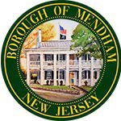
BOROUGH OF MENDHAM MEETING OF THE
MAYORS HISTORIC COMMITTEE
REGULAR MEETING AGENDA
February 25, 2026, 6:00PM
PHOENIX HOUSE, 2 WEST MAIN ST, MENDHAM NJ

CALL TO ORDER/ FLAG SALUTE
ROLL CALL
DISCUSSION ITEMS
- Communications
  - Social media page/ website updates
- Events and Projects
  - Film screening at Garabrant Center
  - Partnering with schools/arts
  - Time Capsule with Rotary Club
  - Labor Day Float
  - Speaker Events
- 2026 Budget
- 250th Flags Update
  - Mendham Business Association
ADJOURNMENT

